SPORTS CLUB

PROJECT OF CSE326

COMPUTER SCIENCE AND ENGINEERING

Submitted by:

NEHA JHA (12221211)

Submitted to:

Miss. ISHA



**LOVELY PROFESSIONAL UNIVERSITY PUNJAB**

**SPORTS CLUB**

Sport is a significant part of life in India. The country has a very long sports history, with sports being a part of tradition, culture, finance and entertainment. People in India closely follow various sports and enthusiastically participate in them. Cricket is the most popular spectator sport in the country, and citizens often play it as a recreational activity; it generates the highest television viewership, and features full-capacity audiences in stadiums during international and [Indian Premier League](https://en.wikipedia.org/wiki/Indian_Premier_League) (IPL) matches. It is part of popular culture. However, in more recent decades, [football](https://en.wikipedia.org/wiki/Football_in_India) has also become another popular sport in terms of broadcast viewership and stadium audience attendance. [Kabaddi](https://en.wikipedia.org/wiki/Kabaddi_in_India) has grown into the mainstream, as well as [badminton](https://en.wikipedia.org/wiki/Badminton_in_India), [tennis](https://en.wikipedia.org/wiki/Tennis_in_India), and [athletics](https://en.wikipedia.org/wiki/Athletics_in_India). India is the one of the power houses in [field hockey](https://en.wikipedia.org/wiki/Field_hockey). India won World Cup & multiple medals in [field hockey](https://en.wikipedia.org/wiki/Indian_field_hockey_team) in Olympics. During that time, [Dhyan Chand](https://en.wikipedia.org/wiki/Dhyan_Chand) was a notable player. Sports such as [swimming](https://en.wikipedia.org/wiki/Swimming_in_India) and [badminton](https://en.wikipedia.org/wiki/Badminton_in_India) are played as recreational activities and for exercise.

India's diversity in culture, people, and tribes is reflected in the wide variety of sporting disciplines in the country. Due to this, some [indigenous sports](https://en.wikipedia.org/wiki/Traditional_games_of_India) are popular in some regions such as [fighter kite](https://en.wikipedia.org/wiki/Fighter_kite) and [boat racing](https://en.wikipedia.org/wiki/Boat_racing) (including [Vallam kali](https://en.wikipedia.org/wiki/Vallam_kali) and [Vallomkali](https://en.wikipedia.org/wiki/Vallomkali)).

Sports such as [golf](https://en.wikipedia.org/wiki/Golf_in_India), [rugby](https://en.wikipedia.org/wiki/Rugby_in_india), [boxing](https://en.wikipedia.org/wiki/Boxing_in_India), kickboxing, [mixed martial arts](https://en.wikipedia.org/wiki/Mixed_martial_arts), and [motorsport](https://en.wikipedia.org/wiki/Motorsport_in_India) are popular to some extent in a few places. [Wrestling](https://en.wikipedia.org/wiki/Wrestling_in_India) was and is popular in some states.

Indians participate in [scuba diving](https://en.wikipedia.org/wiki/Scuba_diving), [boating](https://en.wikipedia.org/wiki/Boating), [surfing](https://en.wikipedia.org/wiki/Surfing_in_India) and [kiteboarding](https://en.wikipedia.org/wiki/Kiteboarding) in coastal tourist areas of [Goa](https://en.wikipedia.org/wiki/Goa) state, [Tarkarli](https://en.wikipedia.org/wiki/Tarkarli) of Maharashtra, Rameshwaram, [Netrani Island](https://en.wikipedia.org/wiki/Netrani_Island) of Karnataka, [Pondicherry](https://en.wikipedia.org/wiki/Pondicherry), [Lakshadweep Islands](https://en.wikipedia.org/wiki/Lakshadweep_Islands) and in [Andaman and Nicobar Islands](https://en.wikipedia.org/wiki/Andaman_and_Nicobar_Islands).

[Professional wrestling](https://en.wikipedia.org/wiki/Professional_wrestling_in_India) and [Mixed Martial Arts](https://en.wikipedia.org/wiki/Mixed_martial_arts) (MMA) are popular sports among young audiences and generate high television viewership. Some Indian wrestlers have achieved great success at the international level in it. MMA sport has been seeing a massive surge in India in the last few years and has gained significant popularity. There are a few MMA [promotions](https://en.wikipedia.org/wiki/Professional_wrestling_promotion) operating in the country.Larger sports clubs are characterized by having professional and amateur departments in various sports such as [bike polo](https://en.wikipedia.org/wiki/Bike_polo), [football](https://en.wikipedia.org/wiki/Association_football), [basketball](https://en.wikipedia.org/wiki/Basketball), [futsal](https://en.wikipedia.org/wiki/Futsal), [cricket](https://en.wikipedia.org/wiki/Cricket), [volleyball](https://en.wikipedia.org/wiki/Volleyball), [handball](https://en.wikipedia.org/wiki/Handball), [rink hockey](https://en.wikipedia.org/wiki/Roller_hockey_(Quad)), [bowling](https://en.wikipedia.org/wiki/Bowling), [water polo](https://en.wikipedia.org/wiki/Water_polo), [rugby](https://en.wikipedia.org/wiki/Rugby_football), [track and field athletics](https://en.wikipedia.org/wiki/Track_and_field_athletics), [boxing](https://en.wikipedia.org/wiki/Boxing), [baseball](https://en.wikipedia.org/wiki/Baseball), [cycling](https://en.wikipedia.org/wiki/Cycle_sport), [tennis](https://en.wikipedia.org/wiki/Tennis), [rowing](https://en.wikipedia.org/wiki/Rowing_(sport)), [gymnastics](https://en.wikipedia.org/wiki/Gymnastics), and others, including less traditional sports such as [airsoft](https://en.wikipedia.org/wiki/Airsoft), [billiards](https://en.wikipedia.org/wiki/Billiards), [e-sports](https://en.wikipedia.org/wiki/E-sports), [orienteering](https://en.wikipedia.org/wiki/Orienteering), [paintball](https://en.wikipedia.org/wiki/Paintball), or [roller derby](https://en.wikipedia.org/wiki/Roller_derby). The teams and [athletes](https://en.wikipedia.org/wiki/Sportsperson) belonging to a sports club may compete in several different leagues, championships and tournaments wearing the same club colours and using the same club name, sharing also the same club [fan base](https://en.wikipedia.org/wiki/Fan_(person)), supporters and facilities.

Many professional sports clubs have an associate system where the affiliated supporters pay an annuity fee. In those cases, supporters become eligible to attend the club's home matches and exhibitions across the entire season, and have the right to practice almost every kind of sport at the club's facilities. Registered associate member fees, attendance receipts, [sponsoring](https://en.wikipedia.org/wiki/Sponsor_(commercial)) contracts, team [merchandising](https://en.wikipedia.org/wiki/Merchandising), TV rights, and athlete/player [transfer fees](https://en.wikipedia.org/wiki/Transfer_(football)), are usually the primary sources of sports club financing. In addition, there are sports clubs, or its teams, which are publicly traded and listed on a [stock exchange](https://en.wikipedia.org/wiki/Stock_exchange) - several professional European football clubs belonging to a larger multisport club are examples of this (namely, Portuguese SADs ([Sociedade Anónima Desportiva](https://en.wikipedia.org/wiki/Sociedade_An%C3%B3nima_Desportiva" \o "Sociedade Anónima Desportiva)) such as [Sport Lisboa e Benfica](https://en.wikipedia.org/wiki/S.L._Benfica) and [Sporting Clube de Portugal](https://en.wikipedia.org/wiki/Sporting_Clube_de_Portugal), or Spanish SADs ([Sociedad Anónima Deportiva](https://en.wikipedia.org/wiki/Sociedad_An%C3%B3nima_Deportiva)) [Real Zaragoza, S.A.D.](https://en.wikipedia.org/wiki/Real_Zaragoza,_S.A.D.) and [Real Betis Balompié S.A.D.](https://en.wikipedia.org/wiki/Real_Betis_Balompi%C3%A9_S.A.D.), as well as Italian clubs like [Società Sportiva Lazio S.p.A.](https://en.wikipedia.org/wiki/S.S._Lazio)).

Some sports teams are owned and financed by a single non-sports [company](https://en.wikipedia.org/wiki/Company), for example the several sports teams owned by [Red Bull GmbH](https://en.wikipedia.org/wiki/Red_Bull_GmbH) and collectively known as [Red Bulls](https://en.wikipedia.org/wiki/Red_Bull_(disambiguation)#Sports_teams_owned_by_Red_Bull_GmbH). Other examples of this are the several sports teams owned by [Bayer AG](https://en.wikipedia.org/wiki/Bayer_AG) and [Philips](https://en.wikipedia.org/wiki/Philips) corporations through the [Bayer 04 Leverkusen](https://en.wikipedia.org/wiki/Bayer_04_Leverkusen) and [PSV Eindhoven](https://en.wikipedia.org/wiki/PSV_Eindhoven) respectively, that originally were [works teams](https://en.wikipedia.org/wiki/Works_team), the teams owned by the [Samsung Group](https://en.wikipedia.org/wiki/Samsung_Group) ([Samsung Sprots](https://en.wikipedia.org/wiki/Samsung_Sports#Amateur)), and the teams owned by the [Anschutz Entertainment Group](https://en.wikipedia.org/wiki/Anschutz_Entertainment_Group) (AEG). They may compete in several different sports and leagues, being headquartered in some cases across several countries.

INTRODUCTION

HTML stand for hyper text markup language. HTML is the most basic building block of the web it defines the meaning and structure of web content. Other technologies besides HTML are generally used to describe a web page appearance or functionally/behavior. “Hypertext” refers to links that connect web pages to one another either within a single website or between websites. Links are a fundamental aspect of the web.

By uploading content to the internet and linking it to pages created by other people you become an active participant in the world wide web. HTML uses “markup” to annotate text, images and other content for display in a web browser. HTML markup includes special “elements” such as <head>,<title>,<body>,<header>,<footer>,<article> and many other. An HTML element is set off from other text in a document by “tags”, which consist of the elements name surrounded by “>” the name of the elements inside a tag is a case insensitive.

That is , it can be written in uppercase, lowercase, or a mixture. For example, the <tittle> or in any other way. However, the convention and recommended practice is to write tags in lower case.

CSS

CSS stands for Cascading Style Sheets, fondly referred to as CSS, is a simply designed languages intended to simplify the process of making web pages presentable. CSS allows you to apply style to web pages. More importantly , CSS enables you to do this independent of the HTML that makes up each web pages. It describes how a webpage should look it prescribe colors, fonts, spacing and much more, in short you can make your website look however you want. CSS lets developers and designer defines how it behaves, including how elements are positioned in the browser. While html, css uses rulesets. CSS is an easy to learn and understand, but it provides powerful control over the presentataion of an HTML document.

HTML is the default language of websites and web-based documents. It helps a browser understand the structure and style of a document or files for viewing over the internet. It allows your web pages to host audio, videos, spreadsheets, and other applications. It also facilitates navigation within web pages or between websites through hypertext. Moreover, website makers can use HTML to design forms for ordering products, making reservations, or searching for information.

HTML is, therefore, the basic building block for building your brand and running an e-commerce site or an online subscription-based business. CSS stands for Cascading Style Sheets. It is the coding language that gives a website its look and layout. Along with HTML, CSS is fundamental to web design. Without it, websites would still be plain text on white backgrounds. Before the development of CSS in 1996 by the World Wide Web Consortium (W3C), Web pages were extremely limited in both form and function. Early browsers presented a page as hypertext - plain text, images and links to other hypertext pages. There was no layout at all to speak of, merely paragraphs running across the page in a single column.

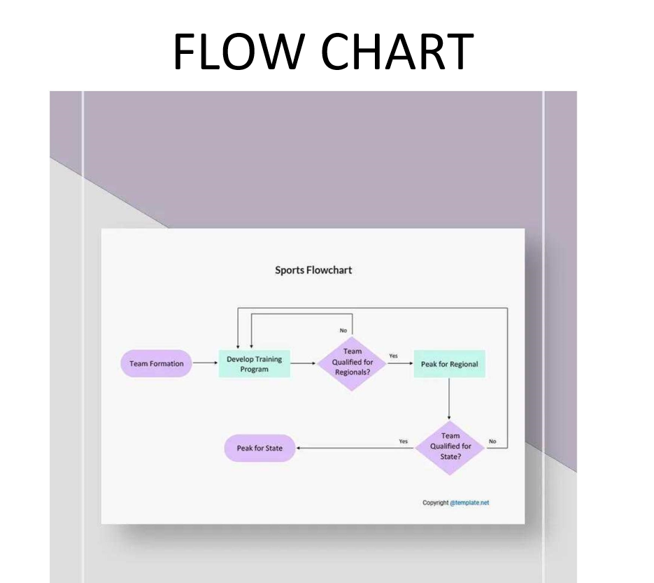

FEATURES :

* WEB FONTS ARE USED TO DECREASE THE SIZE OF THE FILE
* FAST AND RESPONSIVE.

## SOCIAL MEDIA PROFILE AND SHARING FEED

* ADMIRABLE CONTENT AND PRESENTATION
* TOURNAMENT BRACKET

SCREENSHOTS

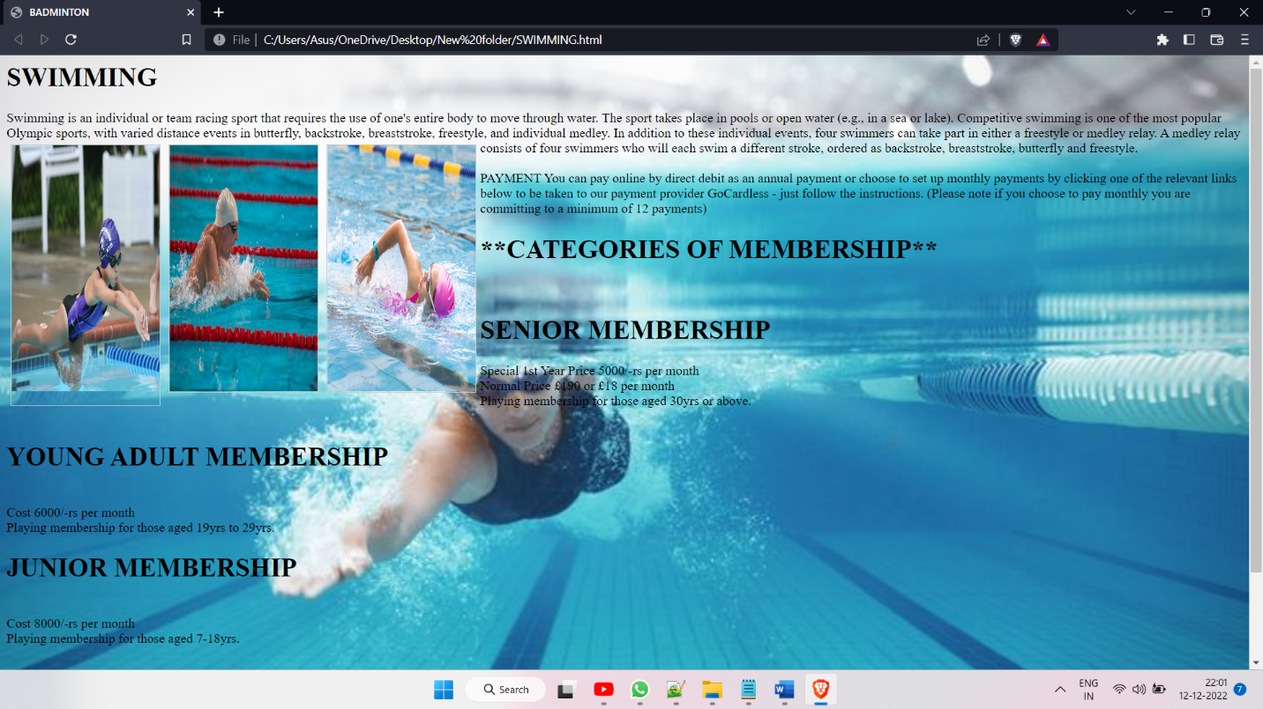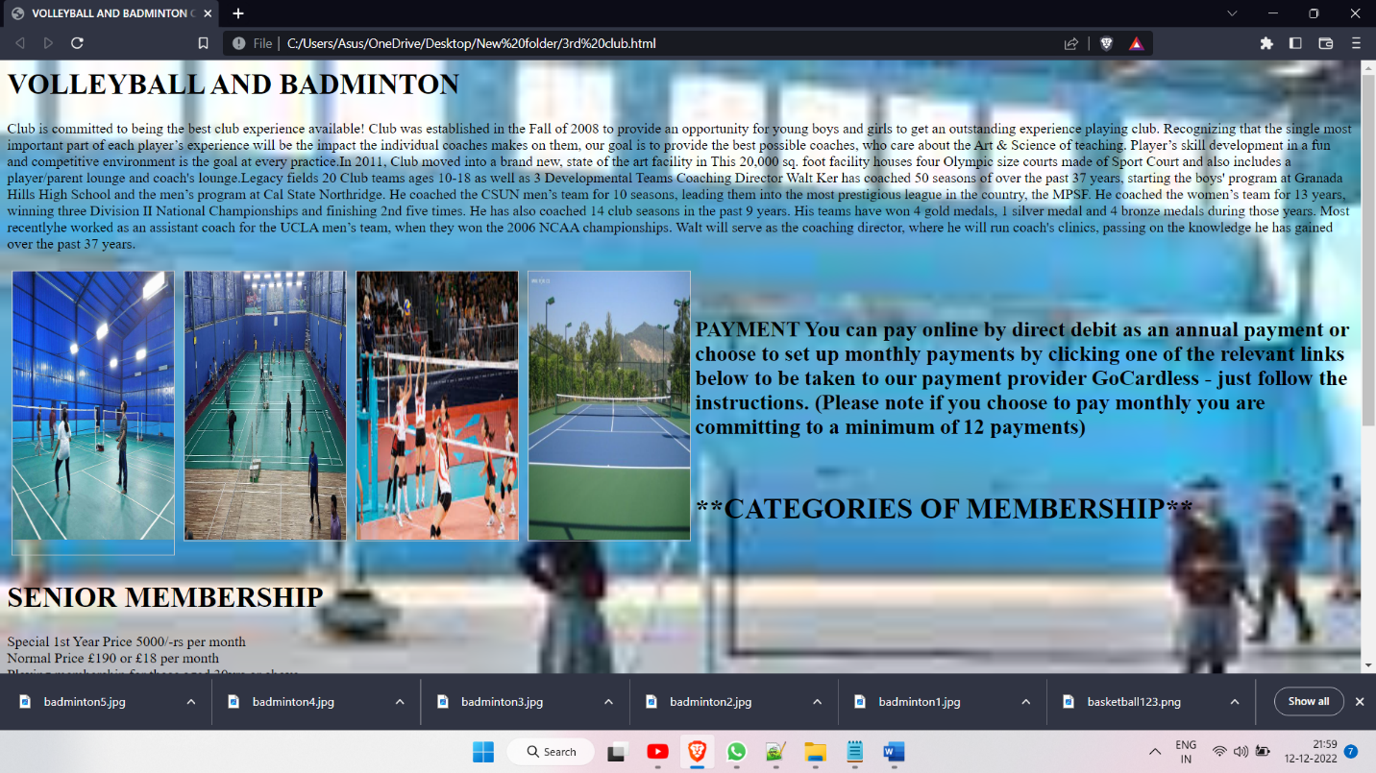

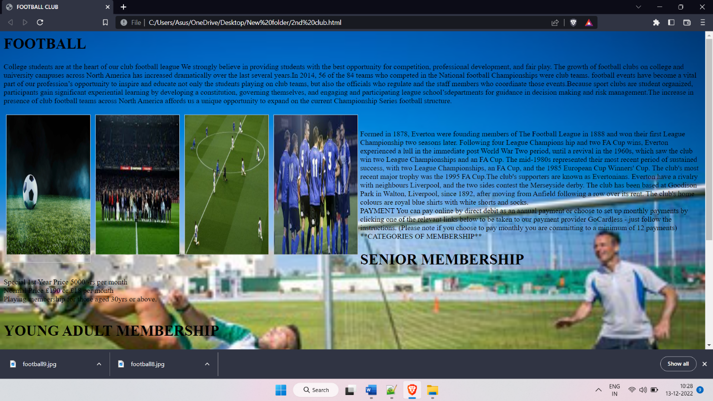

CODE

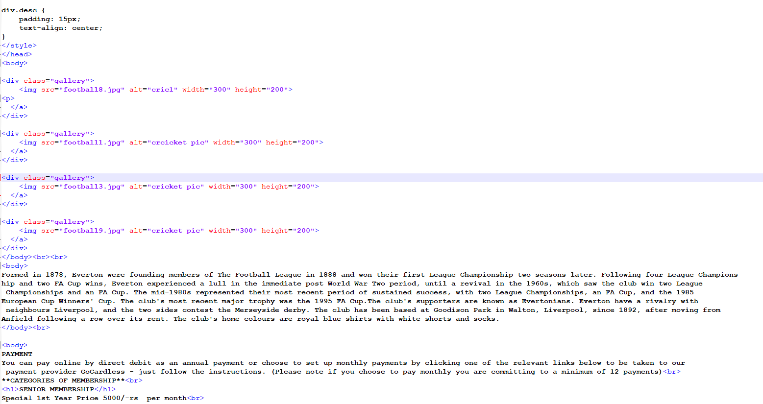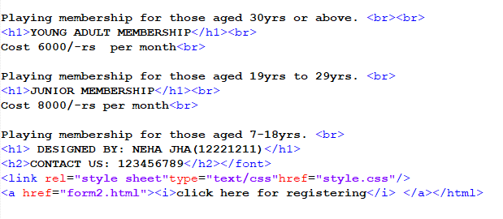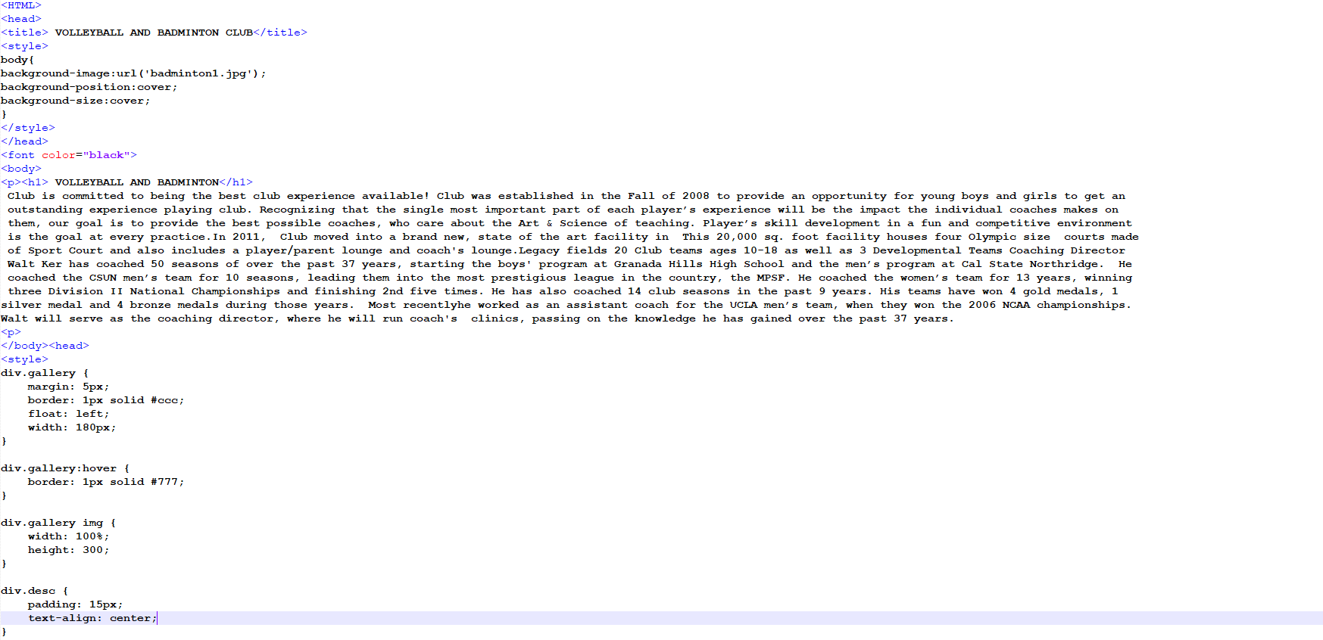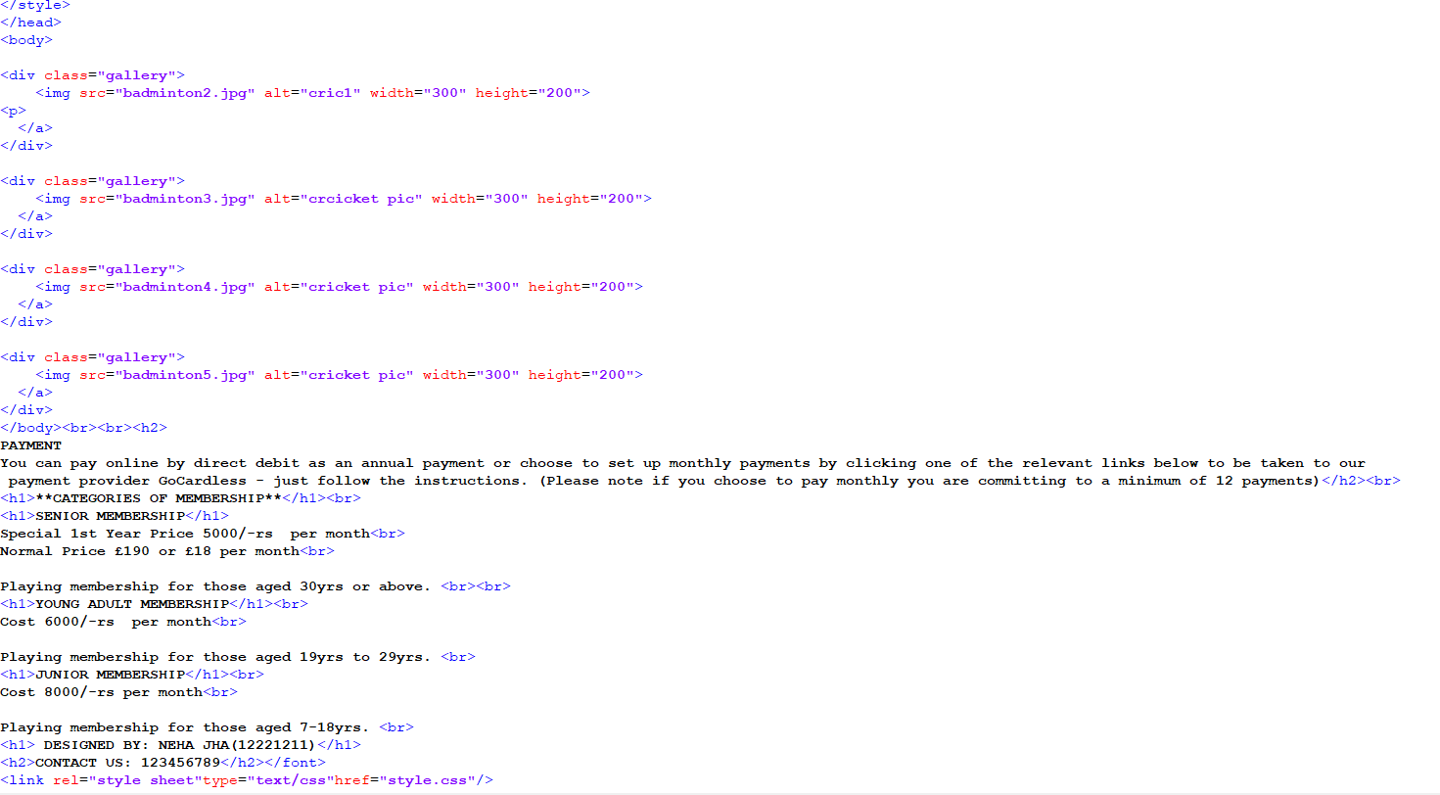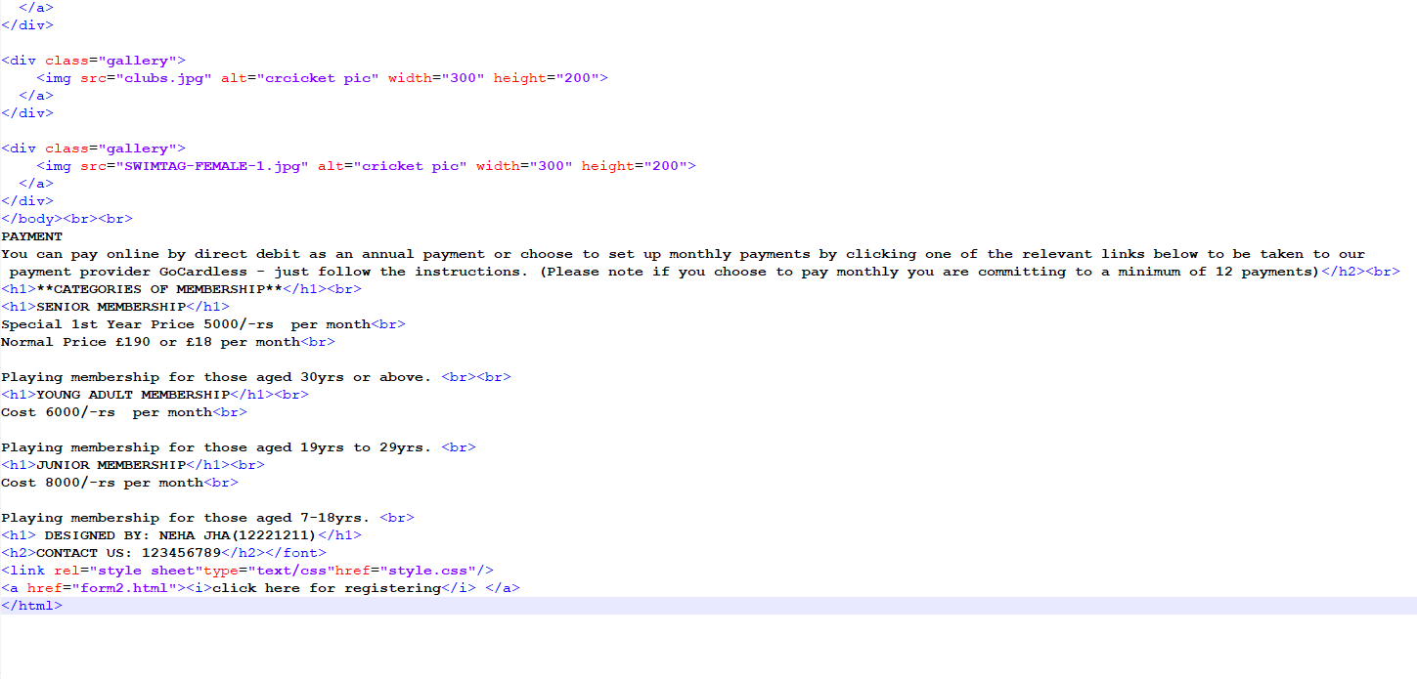

# 

# THANK YOU